**IT1208 - Web Technologies**

**Assignment – 02**

**Conference Registration System**

**System Design and Implementation**

Reg No: 22IT0516

Name: S.M. Perera

Division of Information Technology

Institute of Technology University of Moratuwa

**System Design Overview**

This section explains the architecture and structure of the registration system

The Conference Registration System is designed to facilitate the registration of participants for the "International Research Conference - 2024."

It allows users to submit their details, choose workshops, and complete the registration process.

The system is built using PHP, MySQL, and HTML for the front-end, with a backend that handles form submissions, data validation, and database interactions.

The system consists of the following components:

* Front-End: HTML form with input fields for participant details.
* Back-End: PHP scripts handle the form data, validate it, and interact with the MySQL database.
* Database: MySQL database stores participant details securely.

**1. User Interaction (Front-End)**

The front-end is the part of the system that users interact with directly. It typically consists of a registration form where participants provide personal details, choose workshops, and submit their information.

* **Form Fields**: Includes fields for first name, last name, email, password, phone number, research interests, and comments. There’s also a selection dropdown for workshop options.
* **User Interface (UI)**: The front-end should be responsive and user-friendly, providing an intuitive experience on both desktop and mobile devices. It may also include dynamic elements like a QR code generator.
* **Validation**: Client-side validation ensures that fields like email, phone number, and password follow the correct format before the data is sent to the server.

**Technologies**:

* **HTML**: Used to structure the registration form and interface.
* **CSS**: Provides styling for the form to make it visually appealing.
* **JavaScript**: Enhances user experience by dynamically handling things like form field validation and QR code generation.
* **Font Awesome**: Used for icons in the UI to enhance the design (e.g., icons next to form fields).

**2. Server-Side Logic (Back-End)**

The back-end handles the processing of the form data. It validates the incoming information, interacts with the database to store the participant's details, and ensures that the system functions securely and efficiently.

* **Form Data Processing**: When a participant submits the registration form, the data is sent to the server where PHP scripts process it.
  + **Data Sanitization**: To avoid security risks such as SQL injection, the data is sanitized using methods like real_escape_string().
  + **Password Hashing**: Passwords are not stored in plaintext; they are hashed using password_hash() (bcrypt) for security.
  + **Data Insertion**: The sanitized data is inserted into the MySQL database.
* **Session Management**: After successful registration, users are often redirected to a login page, ensuring a smooth transition between registration and login.

**Technologies**:

* **PHP**: A server-side scripting language used for processing the registration form and interacting with the database.
* **MySQL**: A relational database used for storing participant details securely.

**3. Database**

The database stores all the registration data submitted by the participants. In this system, a MySQL database is used.

* **Participants Table**: This table holds the participant’s personal information such as name, email, phone number, research interests, and workshop choice.
* **Password Security**: Passwords are stored securely by hashing them before storage.
* **SQL Queries**: When a participant submits the form, a INSERT SQL query is executed to store the data in the participants table.

**Database Schema**:

* A table (participants) with columns such as first_name, last_name, email, password, field, phone, research_interests, workshop, and comments.
* **Primary Key**: A unique ID (id) is generated for each participant to uniquely identify them.

**4. Security Considerations**

Security is an important aspect of any system, especially when handling sensitive data such as passwords and personal information.

* **Password Hashing**: The system uses **bcrypt** to hash passwords before storing them in the database. This ensures that even if the database is compromised, user passwords remain secure.
* **SQL Injection Prevention**: The system prevents SQL injection attacks by using prepared statements and escaping user input.
* **Secure Data Transmission**: Ideally, the form submission should occur over HTTPS to ensure the data is securely transmitted between the user’s browser and the server.

**5. QR Code Generation (Optional Feature)**

An additional feature in the registration system could include generating a QR code for each participant, which can be used for event check-ins or as a registration identifier.

* **Dynamic QR Code Generation**: The system can generate a QR code after the participant has registered, embedding key registration details (like name, email, workshop choice) into the QR code.
* **JavaScript Integration**: JavaScript is used to create the QR code on the client side using a library like QRCode.js.

**6. Flow of Data**

* **Form Submission**: The user fills out the registration form and submits it.
* **Data Processing**: The form data is sent to the PHP script on the server.
* **Database Insertion**: The server processes the data, sanitizes it, and inserts it into the MySQL database.
* **Redirection**: After the registration is successful, the user is redirected to a login page.
* **Optional QR Code**: If applicable, a QR code is generated for the participant with their registration details.

**Landing page**



This is the main page that everyone can see. We can register, sign up and go to admin login page through this page.

**Login and Register pages**

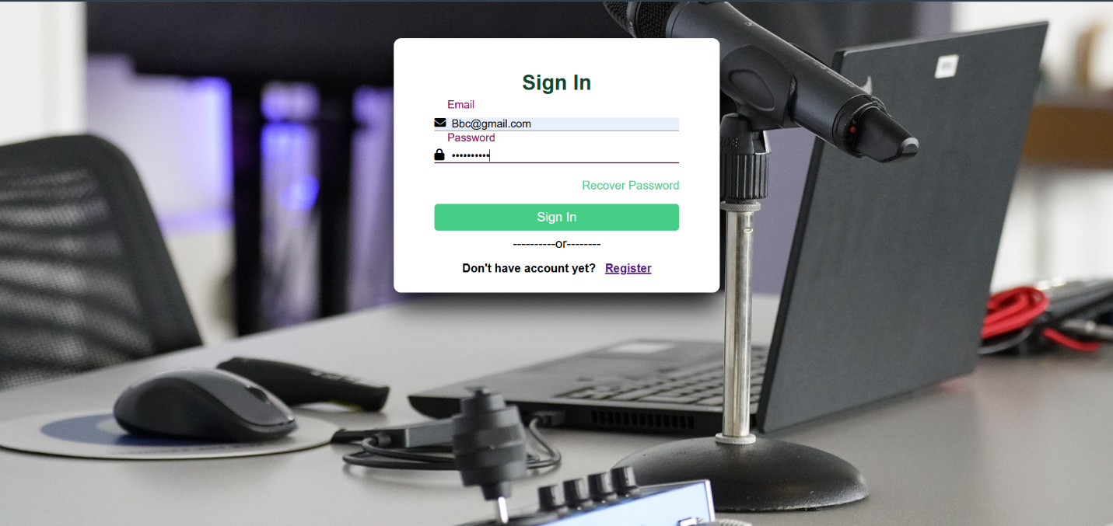

**Dashboard Page**



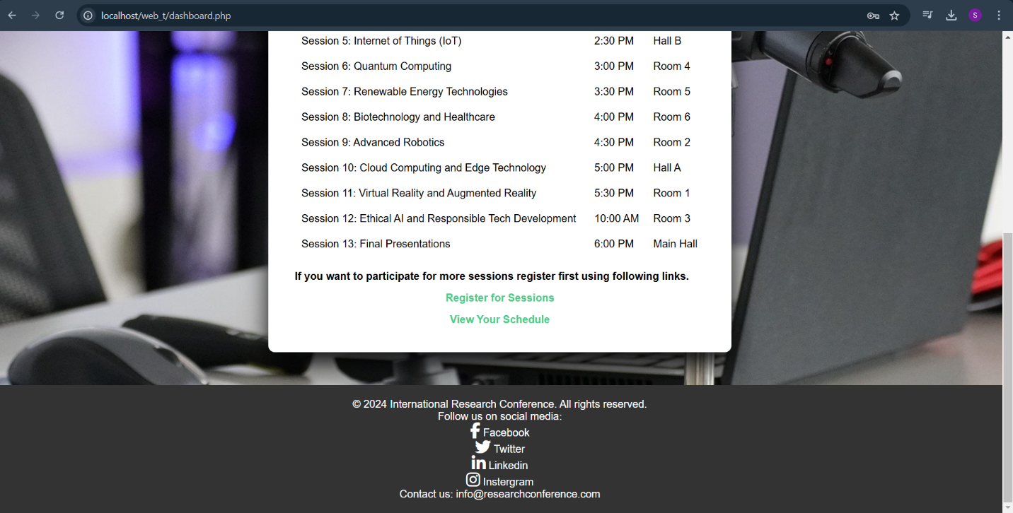

**Session Registration Page**

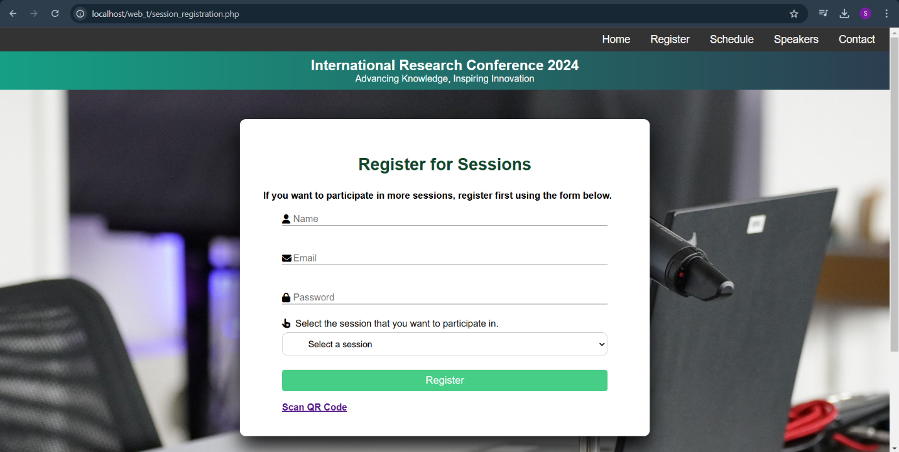

**Technologies Used**

The Conference Registration System was built using the following technologies:

* PHP: A server-side scripting language used for handling form submissions and interacting with the database.
* MySQL: A relational database management system used for storing user data securely.
* HTML/CSS: The front-end technologies used for creating the registration form interface.
* JavaScript: Used for dynamic functionalities like QR code generation.
* Font Awesome: A library for icons used in the user interface.
* QRCode.js: A JavaScript library for generating QR codes dynamically.
* Bcrypt: Used for password hashing to enhance security.

**Database Schema**

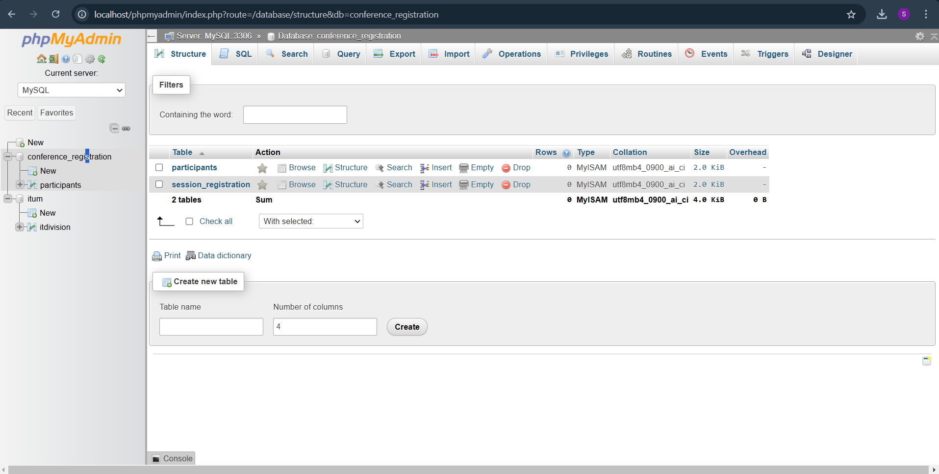

The system had created tables like participants and session registration tables.

When we input data in register form and register for session for database will update.

**Challenges faced and solutions**

1. Data Validation:

Problem: Ensuring that the data submitted by users is accurate and valid, especially for fields like email and phone numbers.

Solution: We used HTML5 input types (e.g., `email`, `tel`) to validate input on the client side and applied additional checks in PHP to ensure data integrity.

2. Security Concerns:

Problem: Securing sensitive information like user passwords.

Solution: Passwords are hashed using the Bcrypt algorithm before storing them in the database to ensure that even if the database is compromised, the passwords remain secure.

3. User Interface Design:

Problem: Ensuring the form is user-friendly and accessible across different devices.

Solution: We used responsive design techniques in CSS, utilizing media queries to ensure the form adapts to various screen sizes.